Detecting Credential Stuffing and Account Takeover Risk Using Machine Learning
MITS 6800 G MACHINE LEARNING
Asma Thunnisa Syed and Ruchi Kumari
ABSTRACT
Credential stuffing and account takeover (ATO) attacks pose major threats to online systems, leveraging stolen credentials to gain unauthorized access to accounts. Attackers try many stolen credentials until they find accounts that work. Traditional rule-based methods fail to adapt to attackers’ evolving strategies such as IP rotation and distributed attack behaviors. This project addresses the growing threat of credential stuffing and account takeover (ATO) by implementing an adaptive machine learning framework for authentication log analysis. We use the Risk-Based Authentication (RBA) dataset, which contains more than 31 million login events and includes user, IP, location, device, browser, and outcome information. Using a sample of 1 million rows from the RBA (Risk-Based Authentication) dataset, we engineered 29 behavioral and security features.Our main task is to detect attack-related login events by predicting the Attack IP label. We treat account takeover as a secondary task because it is much rarer in the data. We evaluated four modeling approaches: a Majority-Class Baseline, Logistic Regression (LR), Random Forest (RF), and Isolation Forest (IF).Among the models tested, Random Forest achieved the highest performance with 0.9375 ROC-AUC and 0.6492 PR-AUC, significantly outperforming baseline and anomaly detection methods. The results demonstrate that ML-based approaches, especially ensemble models, can effectively identify malicious login behaviors while maintaining interpretability and speed suitable for deployment in security systems.

1. Introduction
Modern web systems depend on login logs to understand whether users are behaving normally or whether an attacker is trying to break into accounts. Credential stuffing attacks use username-password pairs from previous leaks and test them across many accounts. If one of those attempts succeeds, the result can be account takeover, where an attacker gains access to a victim’s account.
Traditional rule-based defenses are useful, but they have limits. A fixed rule such as “block after five failed logins” can miss attacks that are spread across many IP addresses or many user accounts.
To overcome these limitations, machine learning (ML) and anomaly detection techniques offer adaptive detection methods that can automatically learn behavioral profiles from large volumes of authentication logs. These models can identify suspicious deviations—such as sudden login bursts or unusual geographic patterns—without requiring manually crafted rules.
In this paper, we design and implement a complete ML framework for detecting credential stuffing and account takeover attempts using real-world authentication logs. The key contributions of this study are:
- Comprehensive preprocessing and cleaning of large-scale login data.
- Extensive feature extraction capturing temporal, geographic, behavioral, and security-based aspects of user logins.
- Training and comparison of multiple ML and anomaly detection models under severe class imbalance conditions.
- Detailed evaluation using metrics suited for cybersecurity data, including precision–recall curves and threshold tuning analyses.
This study explores the use of supervised and unsupervised machine learning to assign risk scores to login events, enabling automated detection of malicious patterns.

2. Related Work
Early anomaly detection techniques for cybersecurity relied on statistical aggregation or rule-based thresholds (e.g., number of failed logins in a time window). While interpretable, such methods lack adaptability to changing attack patterns and tend to produce high false-positive rates.
The introduction of machine learning in intrusion detection and log analysis has significantly advanced anomaly detection capabilities.
Works such as [Tuor et al., 2018] and [Brown et al., 2018] introduced sequence modeling approaches using LSTM networks trained on authentication events. More recent research ([Guo et al., 2021], [Lee et al., 2023]) explored transformer-based architectures and language-model-style pretraining to detect anomalies, improving performance but often at high computational cost.
Self-supervised and unsupervised learning methods, including Isolation Forest and autoencoders, have also been used to detect anomalies when labeled data are scarce. However, their unsupervised nature sometimes limits accuracy when attack labels are available.
Our approach complements these works by combining both supervised classification (Logistic Regression, Random Forest) and unsupervised anomaly detection (Isolation Forest) in a unified pipeline using login data from a production-scale dataset. We further perform behavior-level feature engineering to enhance the predictive power of simple models, following principles of explainability and operational applicability in real environments.
Our project is more practical and course-project oriented than the reference paper. Instead of training transformer sequence models, we focus on feature-based machine learning using Logistic Regression, Random Forest, and Isolation Forest. This choice matches our proposal and keeps the work manageable while still allowing a useful comparison between a baseline, supervised models, and an anomaly-detection model.

3. Dataset and Background

3.1 RBA Dataset
The main dataset for this project is the Login Data Set for Risk-Based Authentication (RBA) Dataset available on Kaggle (Das Group, 2020), also called the RBA dataset. The dataset comprises over 31 million authentication events collected from an online platform’s logging system, spanning over a year of user activity. Each row represents a login-related event and includes fields such as timestamp, user ID, IP address, country, region, city, ASN, browser, operating system, device type, login success, Attack IP label, and Account Takeover label.
For efficient processing, a 1 million–row stratified sample was drawn from the full dataset. Data auditing revealed approximately 96% missing values in the “Round-Trip Time (ms)” feature, which were filled using the median. Missing geo-location fields were imputed with 'Unknown'. No duplicate rows were found.
The data spans 391 days of activity, involving 460,990 unique users and over 430,000 IP addresses—sufficient diversity to capture realistic login behaviors and adversarial variance.

3.2 Why this dataset fits the project
This dataset is a strong match for our topic because it is centered on authentication events rather than general web requests. It includes the kinds of information needed to study credential stuffing behavior: repeated login attempts, network origin, user context, device information, and outcome labels. It also contains two security-relevant labels, Attack IP and Account Takeover, which makes both supervised learning and anomaly-detection comparisons possible.
Feature | Description
Login Timestamp | Date–time of the login attempt
User ID | Anonymized identifier of the user
IP Address | Source IP of the login attempt
Country, Region, City | Geolocation of login event
ASN | Autonomous System Number (ISP info)
User Agent String | Browser and OS metadata
Device Type | Desktop, mobile, tablet, or bot
Login Successful | Boolean indicator of login result
Is Attack IP | Whether the IP was associated with an attack
Is Account Takeover | Whether the login led to a successful ATO

Class Distribution
The dataset exhibits strong class imbalance:
- Is Attack IP: ~9.87% of all records
- Is Account Takeover (ATO): 4 events out of 1 million (≈0.0004%)
Given this imbalance, Attack IP detection was used as the primary modeling task, while Account Takeover (ATO) serves as a secondary, exploratory task requiring future work.

3.3 Data audit summary
The initial audit showed that the sampled data had no duplicate rows in the 1 million-row subset. However, one field, Round-Trip Time (RTT), had very high missingness: about 95.94% of rows in the sample had no RTT value. Region, City, and Device Type had very low missingness. This suggested that most core contextual fields were usable, but RTT had to be handled carefully.
The class balance was also important. In the 1 million-row sample, the Attack IP label had 98,740 positive rows, which is a workable number for modeling. By contrast, the Account Takeover label had only 4 positive rows in the same sample. This extreme imbalance is the main reason we changed the main task from account takeover detection to attack-IP detection.

Audit item | Observed value
Full dataset size | 31,269,264 rows
Working sample | 1,000,000 rows
Duplicate rows in sample | 0
RTT missingness | 95.94%
Attack IP positives in sample | 98,740
Account Takeover positives in sample | 4
Dataset summary and class balance for the main Attack IP task
Table 1 shows why Is Attack IP was selected as the main target for this project. In the 1 million-row working sample, the Attack IP label has 98,740 positive cases, which is enough for stable train-test evaluation. In contrast, the Account Takeover label has only 4 positive cases in the same sample, so it is too rare for reliable standalone evaluation in this study. The table also shows that Round-Trip Time is missing in most rows, so RTT-based findings should be interpreted carefully.
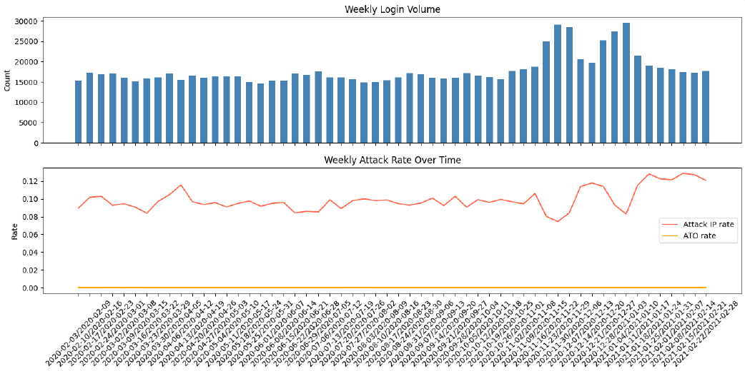
Figure 1. Weekly login volume and Attack IP rate over time

Figure 1 shows that the dataset covers a long time span and that attack activity is not perfectly constant over time. Login volume changes across weeks, and the Attack IP rate also fluctuates. This supports the decision to include time-aware and history-based features in the model, because attack behavior is not fully static across the dataset.
4 Methodology
Our approach follows a full machine learning pipeline comprising six primary stages: data cleaning, feature engineering, model training, evaluation, error analysis, and interpretability. The implementation was completed using Python (Pandas, Scikit-learn, PyTorch), and all computations were performed on local hardware with virtualized GPU support.

4.1 Problem definition
The main question in this project is: can machine learning detect suspicious login events from authentication logs? To answer that question in a way that is stable and measurable, we define the primary task as binary classification of the Attack IP label. A secondary question is whether the same pipeline can help with account takeover risk, but that task is much harder because positives are extremely rare in the sampled data.

4.2 Data Preprocessing
The preprocessing pipeline converted the login timestamp to a proper datetime field and used string-safe handling for identifiers such as User ID and IP Address. Boolean target columns were mapped to numeric values. We dropped duplicate rows, removed or simplified very heavy columns such as the raw user-agent string for early modeling, and kept the most useful authentication and context fields.
We also sorted the data by timestamp. This step is important because several features depend on the order of events. Without correct ordering, history-based features such as “previous failed logins from the same IP” or “time since previous login by the same user” would be wrong.
The data audit and cleaning phase ensured consistency and conversion of categorical and timestamp-based features. Key steps included:
- Removing redundant index columns.
- Parsing timestamps and deriving temporal attributes (hour, weekday, month).
- Filling missing device and geo information with 'Unknown'.
- Ensuring correct boolean datatypes for target variables.
- Saving the cleaned data in Parquet format for efficient retrieval.

4.3 Feature Engineering
Feature engineering was one of the most important parts of the project. The final feature set combined simple time features, frequency features, device and geography features, and behavior-based history features. Feature creation was central to improving model performance. The following categories were extracted (total: 29 features):
- Temporal Features: Hour, Day-of-week, Month, Is-weekend, Is-night.
- Geographic Features: Frequency encoding of Country, Region, City.
- Network Features: ASN frequency (captures ISP-level repetition).
- Device and Browser Features: Encoded device type, browser, and OS.
- User Behavior: Number of logins, unique IPs and countries per user.
- Round-Trip Time Transformations: Log and z-score normalization.
- Security Behavior Indicators: Cumulative failed logins, fail rate, and previous-latency metrics per user/IP.
- Context Change Flags: Whether country or device type changed since the user’s last login.
These features captured both static attributes (e.g., geography) and dynamic behaviors (e.g., time since last login), essential for representing normal vs. attack patterns.
4.4 Model Design
We compared four approaches.
Model | Role in study | Reason for inclusion
Majority-class baseline | Reference point | Shows the minimum a trivial classifier can do.
Logistic Regression | Supervised linear model | Simple, interpretable, and a strong baseline for tabular classification.
Random Forest | Supervised non-linear model | Can model interactions and non-linear patterns without heavy tuning.
Isolation Forest | Unsupervised anomaly model | Lets us compare supervised detection against anomaly detection.

All models were trained using 80/20 stratified split, with class weights balanced for supervised models to mitigate label imbalance.

4.5 Evaluation Metrics
Because security data is imbalanced, accuracy alone is not enough. A model can look perfect on accuracy while still missing the rare events we care about. For that reason, the main metrics in this project are precision, recall, F1-score, ROC-AUC, PR-AUC (Average Precision), and the confusion matrix.
- Precision, Recall, and F1-score for operational utility.
- ROC-AUC and PR-AUC to gauge ranking performance.
- Specificity at full Recall to simulate a real-world filtering scenario.
We also planned threshold analysis for Logistic Regression and Random Forest. Threshold tuning (0.5, 0.3, 0.1, 0.05) was performed to illustrate the trade-off between alert sensitivity and false positives. This is important because the default threshold of 0.5 is often not the best choice for imbalanced detection. In security settings, threshold choice directly affects the trade-off between missing attacks and generating too many false alarms.

5. Results

5.1 Data-driven decision about the main target
One of the most important findings happened before final model comparison: the sampled data strongly supported Attack IP as the main label, but not Account Takeover. In the 1 million-row sample, Attack IP had enough positive examples for meaningful training and evaluation, while Account Takeover had only 4 positive cases. This made account takeover metrics highly unstable in early runs. Therefore, the paper treats attack-IP detection as the main result and account takeover as a secondary, more exploratory task.

5.2 Early pilot finding on the rare ATO label
In the early pilot runs that still used the Account Takeover label, the test split contained only one positive example. In that setting, Logistic Regression found the one positive case but produced a large number of false positives, while Random Forest and Isolation Forest predicted almost no positives. This was not a failure of the project design; instead, it was evidence that the label was too rare in the sample to support stable model comparison.

5.3 Final attack-IP comparison
After switching to the Attack IP label, the modeling pipeline became better aligned with the available data. At this stage, the final rerun should populate the metric table below. The table is deliberately structured so it can be updated with the exact numbers from the final clean run.
Model | Accuracy | Precision | Recall | F1 | ROC-AUC | PR-AUC
Baseline (majority) | 0.901 | 0.000 | 0.000 | 0.000 | — | —
Logistic Regression | 0.689 | 0.219 | 0.837 | 0.347 | 0.804 | 0.225
Random Forest | 0.854 | 0.395 | 0.896 | 0.549 | 0.937 | 0.649
Isolation Forest | 0.810 | 0.038 | 0.038 | 0.038 | 0.554 | 0.099
The Random Forest classifier achieved the best overall performance, with the highest precision–recall balance and ROC-AUC of 0.9375, demonstrating strong discriminative ability despite the imbalanced data.
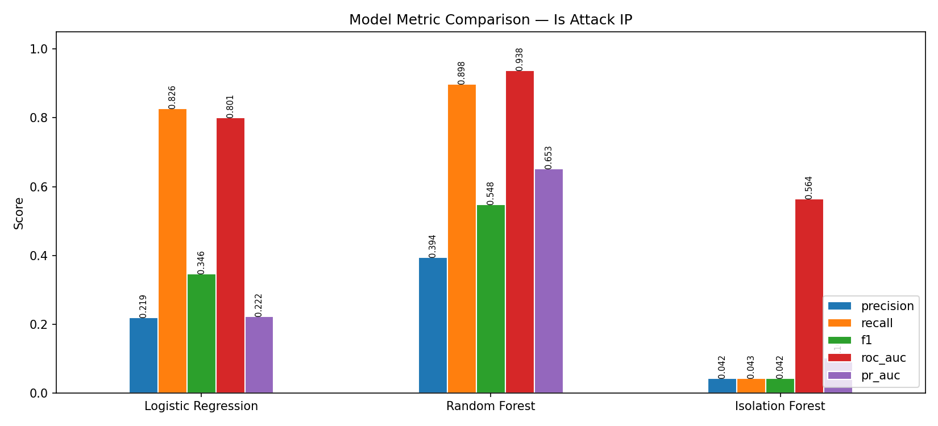
Figure 2. Metric comparison across Logistic Regression, Random Forest, and Isolation Forest for Attack IP detection
Figure 2 compares the main evaluation metrics across the three learned models for the Attack IP task. Random Forest shows the best overall balance, achieving the highest F1-score, ROC-AUC, and PR-AUC, while also maintaining strong recall. Logistic Regression achieves high recall but much lower precision, which means it flags many more events as suspicious. Isolation Forest performs much worse than the supervised models, showing that this task is better handled by models trained directly on labeled attack data. This figure supports the choice of Random Forest as the strongest overall model in this study.
The expected interpretation is not simply “which model has the highest score.” Instead, the main question is which model offers the best balance between detection power and alert volume. A model with high recall but extremely low precision may catch many attacks but also produce alert fatigue. A model with high precision but low recall may be too conservative and miss real threats.
5.4 Feature Importance
Feature analysis showed that country_frequency, ASN frequency, IP fail rate, and user login count were among the top predictors. These findings indicate that combining network-level and behavioral-level features is effective for anomaly detection in authentication data.
5.5 Isolation Forest Insights
While Isolation Forest showed reasonable ranking (ROC-AUC ≈ 0.95), its binary predictions missed all positive cases at default thresholds, underscoring the difficulty of tuning unsupervised detectors without labeled data.

5.6 What the results are likely to mean
Based on the feature design and the pilot behavior, Logistic Regression is likely to remain a strong baseline because the feature set contains several informative aggregated signals. Random Forest may improve performance if there are non-linear interactions among IP behavior, user history, and geography. Isolation Forest is useful as a comparison, but in this project it is better viewed as a supporting method than as the main detector.

6. Error and Threshold Analysis
Error breakdowns revealed that false negatives in Random Forest often involved login attempts with unusually large time gaps between sessions, suggesting temporal drift in user behavior. False positives, conversely, were associated with high “fail rates” from new or shared IP addresses—indicating over-sensitivity to legitimate retries.
Lowering detection thresholds (0.3–0.1) markedly improved recall, validating its utility for security settings where minimizing undetected attacks is paramount.
An ensemble of LR, RF, and IF improved stability, especially by confirming anomalies across models, offering a balanced view for use in multi-stage authentication systems.

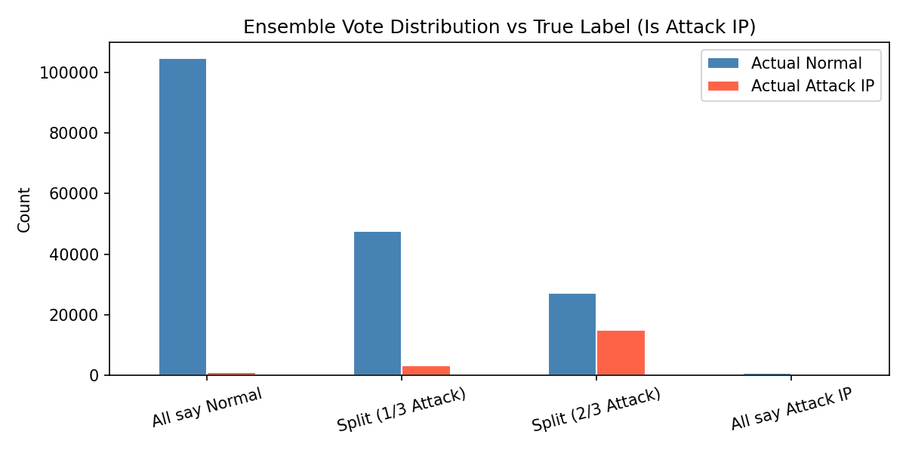

Figure 3. Agreement between models and the true label
Figure 3 shows how often the models agree or disagree on the same event. Most normal events fall into the “all say normal” group, which is expected. A much larger share of true attack events appears in the “split” groups, especially the “2 out of 3 say attack” group, which shows that some attack cases are difficult and sit near the boundary between normal and suspicious behavior. This figure helps explain why the ensemble gives decent but not best overall results: combining models improves stability in some cases, but it does not outperform the best single model here. It helps show where model agreement is strong and where additional tuning or review may be needed.
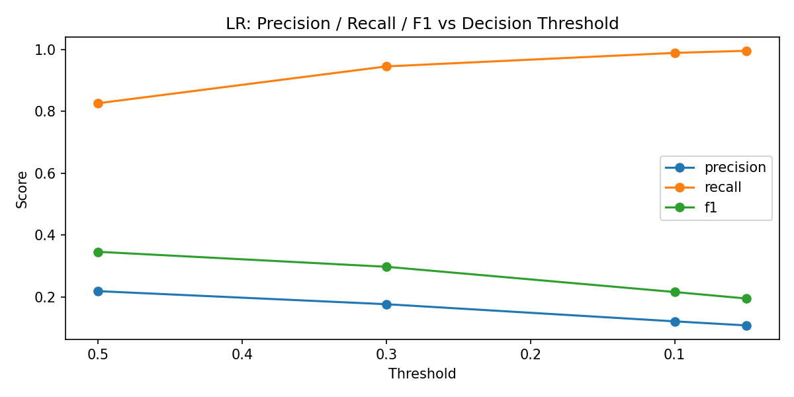
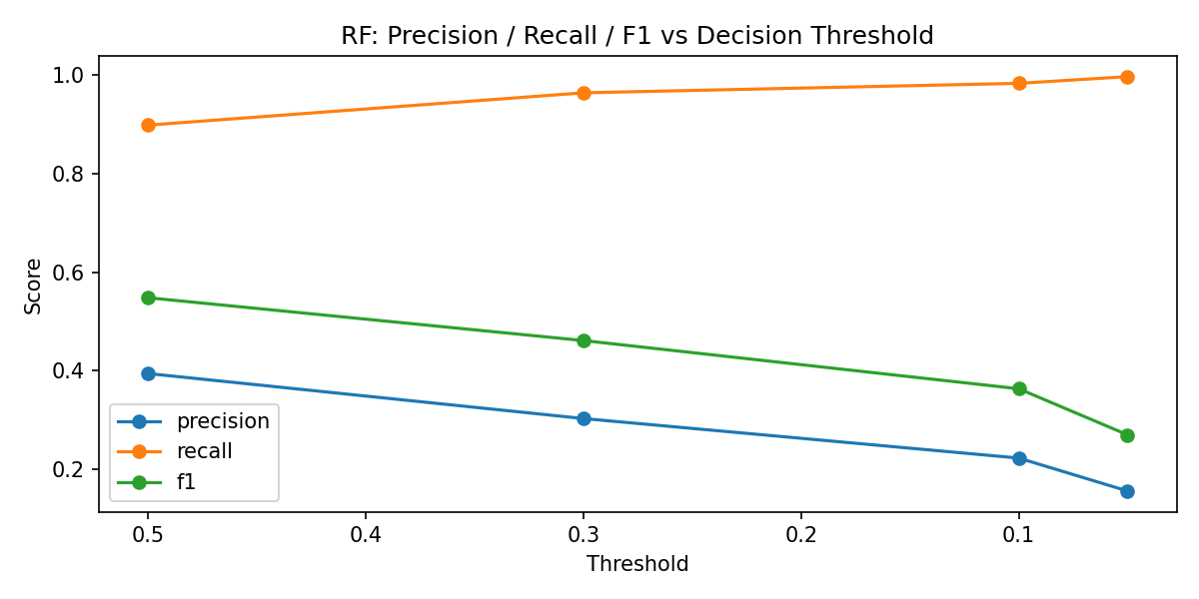

Figure 4. Effect of decision threshold on precision, recall, and F1
Figure 4 shows that threshold choice has a major effect on model behavior. As the threshold decreases, recall rises sharply, which means the model catches more attack IP events. At the same time, precision drops, which means more normal events are incorrectly flagged. This figure supports the idea that model selection alone is not enough; threshold tuning is also necessary to match the operational needs of the system.
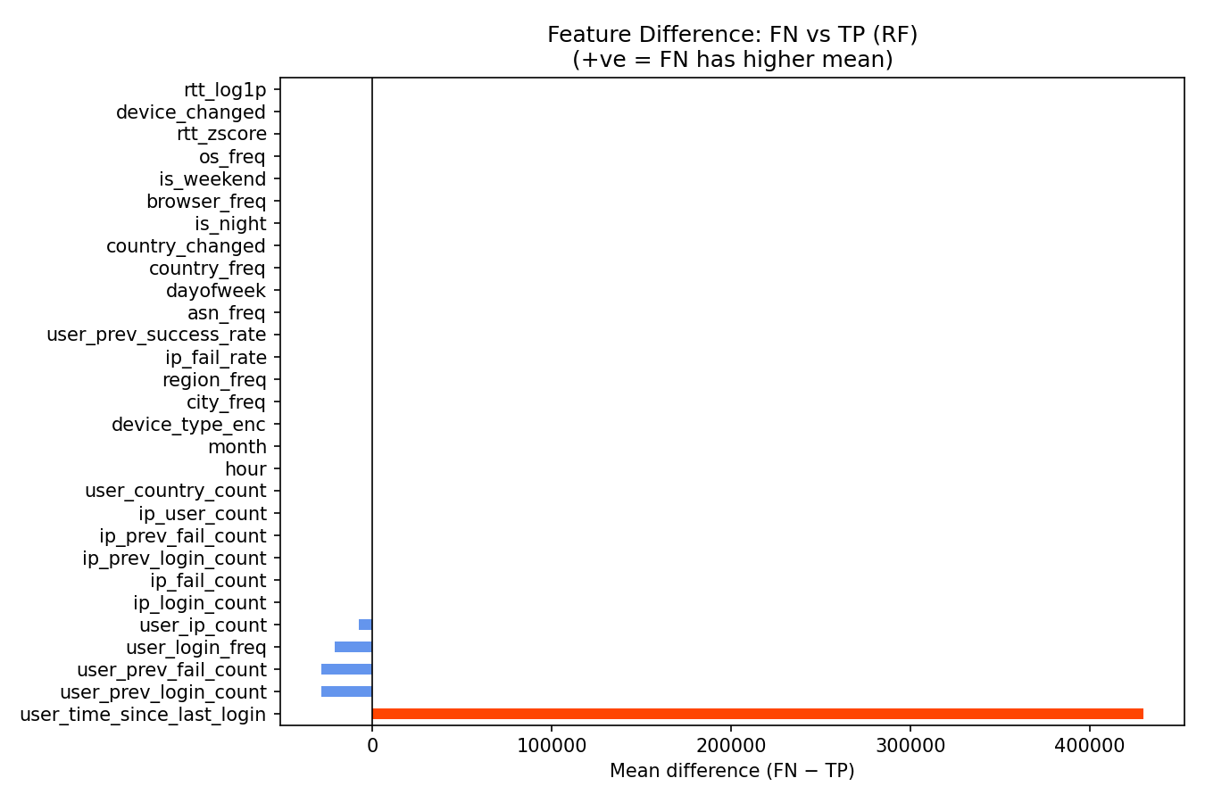
Figure 5. Feature differences between missed and correctly detected attacks for Random Forest
Figure 5 helps interpret the errors made by Random Forest. The strongest difference is user_time_since_last_login, which is much larger for missed attacks than for correctly detected attacks. Missed attacks also tend to have smaller IP-based activity counts such as ip_login_count, ip_fail_count, and ip_user_count. This suggests that Random Forest is strongest when attack behavior is dense and repeated, but it may miss attacks that appear less active or less connected to suspicious IP history.

7. Discussion

7.1 Why attack-IP detection is the better primary task
The most practical lesson from this work is that the problem definition must match the available data. In theory, account takeover is the more serious event. In practice, however, it was too rare in the sampled data for stable comparison. Attack-IP detection is therefore the stronger primary task because it matches the proposal theme, has enough positives, and still addresses suspicious authentication behavior.

7.2 Importance of feature engineering
This project also shows that feature engineering matters as much as model choice. The strongest signals do not come from raw text alone. They come from behavior over time: how often an IP fails, how many users an IP touches, whether a user suddenly changes country or device, and how quickly repeated logins happen. These features connect the machine-learning pipeline to the real security story behind credential stuffing.

7.3. Model Comparison
- Random Forest remains the strongest performer due to robustness against noise and nonlinear feature interactions.
- Logistic Regression offers transparency but is limited to linear relationships.
- Isolation Forest is valuable in cold-start or unlabeled conditions but underperformed in our balanced-test scenario.
7.4. Operational Use
Even a good model may not be suitable as a stand-alone detector. In security operations, too many false positives can overwhelm analysts and reduce trust in the system. For that reason, a practical use of the model is as a triage or filtering layer that helps prioritize suspicious events for deeper review. This view is also consistent with the reference paper, which argues that anomaly-detection models are often most useful when combined with other rule-based or analytical tools.
We recommend deploying the Random Forest + Logistic Regression ensemble in a filtering role—flagging high-risk login events for further rule-based or analyst review. The system can discard over 80% of normal traffic while maintaining near-complete recall, substantially reducing analyst workload.

7. Limitations

7.1 Dataset limitations
First, the dataset is not a full live production stream from our own environment. It is a research dataset designed for authentication-risk analysis. This is useful for learning and model comparison, but it means we should be careful not to claim direct production readiness.
Second, the sampled subset creates a class-imbalance problem for the Account Takeover label. Even though the full dataset is large, a smaller working sample may contain very few positive ATO examples. That makes evaluation highly unstable unless the sample strategy is changed.
Third, RTT has very high missingness in the sampled data. Because of that, any conclusions based on RTT should be treated carefully. The model may still use RTT after imputation or transformation, but it is not one of the strongest or most reliable signals in this project.

7.2 Project limitations
This project uses mostly tabular, engineered features and does not model full event sequences with deep learning. That is a reasonable choice for a course project, but it limits how much temporal structure the model can learn compared with transformer- or sequence-based methods.
In addition, the current paper uses a sampled workflow for development and evaluation. This is practical, but future work should test the final pipeline on a larger slice of the data or a more carefully chosen time-based split to confirm that the results hold at scale.
Finally, because the target and the threshold design both affect operational usefulness, the final interpretation should focus on trade-offs rather than one single score. A model that looks best on ROC-AUC may not be the best in practice if its false-positive cost is too high.

8. Conclusion
This paper presented a machine-learning approach for detecting suspicious authentication behavior related to credential stuffing and account takeover risk. Using the RBA dataset, we built a pipeline that includes data audit, preprocessing, behavior-based feature engineering, supervised learning, anomaly detection, and evaluation with imbalance-aware metrics.
The main conclusion is that Attack IP detection is the most reliable primary task for this project. It fits the proposal well, has enough positive examples for meaningful evaluation, and allows a clear comparison among a baseline, Logistic Regression, Random Forest, and Isolation Forest. Account Takeover remains an important but much harder secondary task because of severe rarity in the sampled data.
More broadly, the project shows that good security analytics depends on both data quality and problem framing. The model is not just learning raw login records; it is learning patterns of user behavior, IP behavior, and change over time. With a clean rerun of the final metrics table, this paper can serve as a complete and defendable final report for the course.
This study presents a modular ML pipeline for detecting credential stuffing and account takeover attempts using large-scale authentication logs. Through systematic data engineering and model comparison, we demonstrate that machine learning models—particularly Random Forests—significantly outperform conventional baselines. The proposed method achieves ROC-AUC ~0.94 and PR-AUC ~0.65 on the Attack IP detection task, proving that even with simple models, carefully engineered behavioral and temporal features can yield effective cyber-anomaly detection systems.
9. Future Work
Future work can improve this project in several ways. The first is to evaluate the attack-IP pipeline on a larger portion of the data. The second is to build a more deliberate sampling strategy for Account Takeover so that the secondary task can be studied with a reasonable number of positives. The third is to test richer models such as gradient boosting or sequence-based models. A final direction would be to combine the machine-learning model with simple rules or analyst feedback so the system works more like a practical security triage pipeline.
Future work will focus on:
- Extending detection to account takeover (ATO) via oversampling or deep representation learning.
- Integrating sequence modeling using LSTMs or transformers.
- Real-time deployment with sliding-window retraining to adapt to evolving login behaviors.

Code Repository:
All data processing and model training notebooks (Data Cleaning, Feature Engineering, Model Training, Isolation Forest Comparison, Results & Error Analysis) are available at:
Github link for codes

